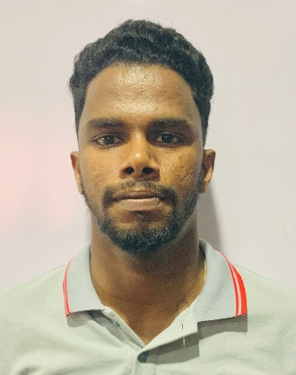
CONTACT
  
+94 77
94
84218
  
No 11 Ukkalla Uduwara
Aguruwathota.

PERSONAL DETAILS
Name In Full
WIMALASINHAGE ASITHA DILSHAN
Date of Birth
21
^{th}
February 2001
Age
years
24
Gender
Male
NIC Number
200105201560
Religion
Buddhism
Maritial Status
Unmarried
Nationality
Sri Lankan
LANGUAGE SKILLS

Communication in Sinhala

Communication in English

PERSONAL SUMMARY
A highly and hard working individual looking for a
responsible position to gain practical experience
and secure a responsible career opportunity to fully
utilize my training and skills, while making a signifi-
cant contribution to the success of the company.
KEY SKILLS

Good communication skills.
Leadership skills

Team Player

Hardworking & Reliable

Attention to detail

Self-motivated
Work under Pressure

Loyal to the employer

EXPERINCE

5 Years Experince Hayleys Fabric Finish Goods Warehouse

EDUCATION QUALIFICATION

Passed G.C.E (O/L) Examination.

C3
S4

W2

DECLARATION

I hereby certify that the information provided in
this from is complete,true and correct to the best of
my knowledge.
W.A DILSHAN
W.A DILSHAN

